**TEAM ID: LTVIP2025TMID52116**

**NAME: Kiran Reddy Nalamaru**

**ASSIGNMENT-1**

**1.Bar Chart**

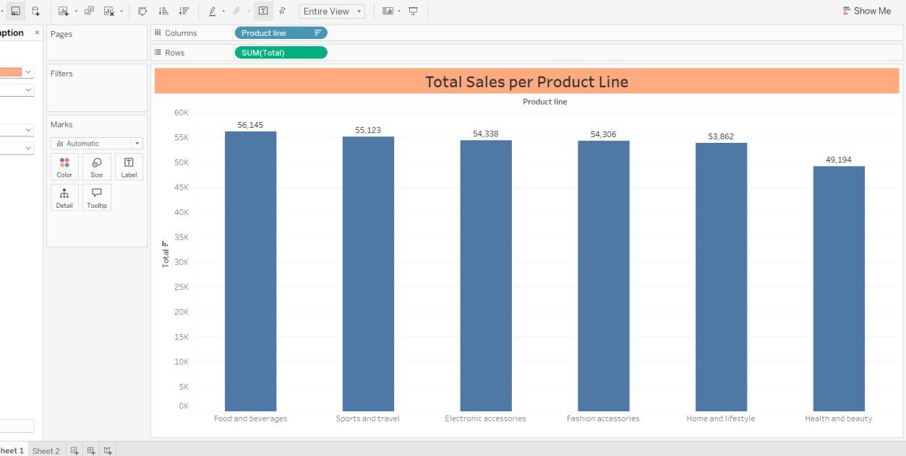

**2.Pie Chart**

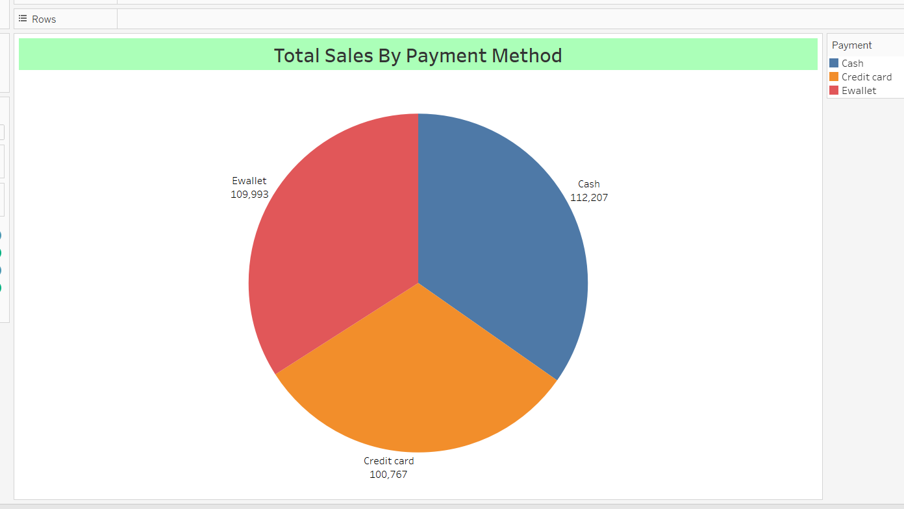

**3.Stacked Bar Chart**

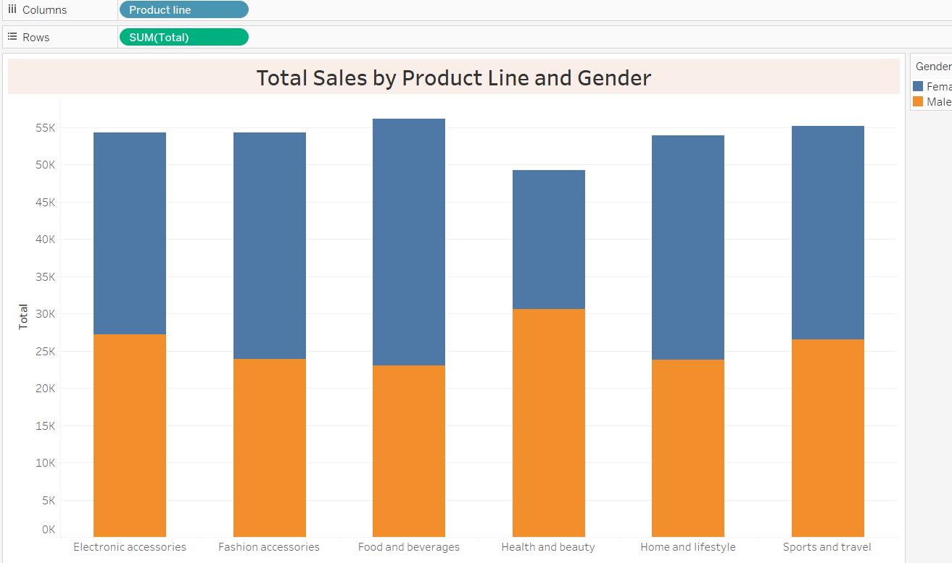

**4.Line Chart**

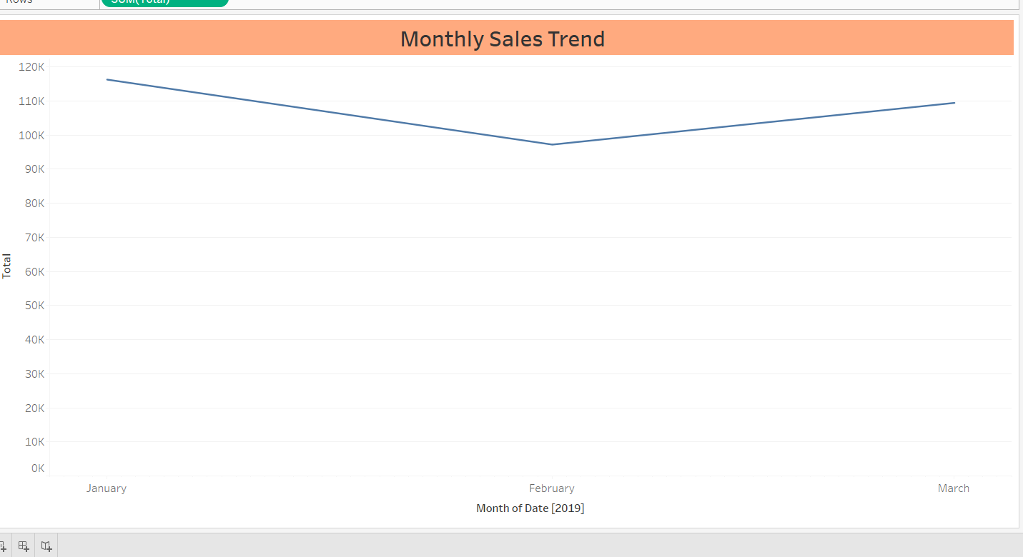 H

**5.Bubble Chart**

